EXPERIMENT 5  
Reg. no.: 220929254  
Roll no.: 51  
Tanirika Pal

**Exercise Question 1:** Develop an algorithm for 2 sensors in a manufacturing plant to indicate the entry and exit of an object over a conveyor belt to the main server which is a receiver controlled by human. Use on-board pushbuttons as the sensors, when pressed the detection should happen.  
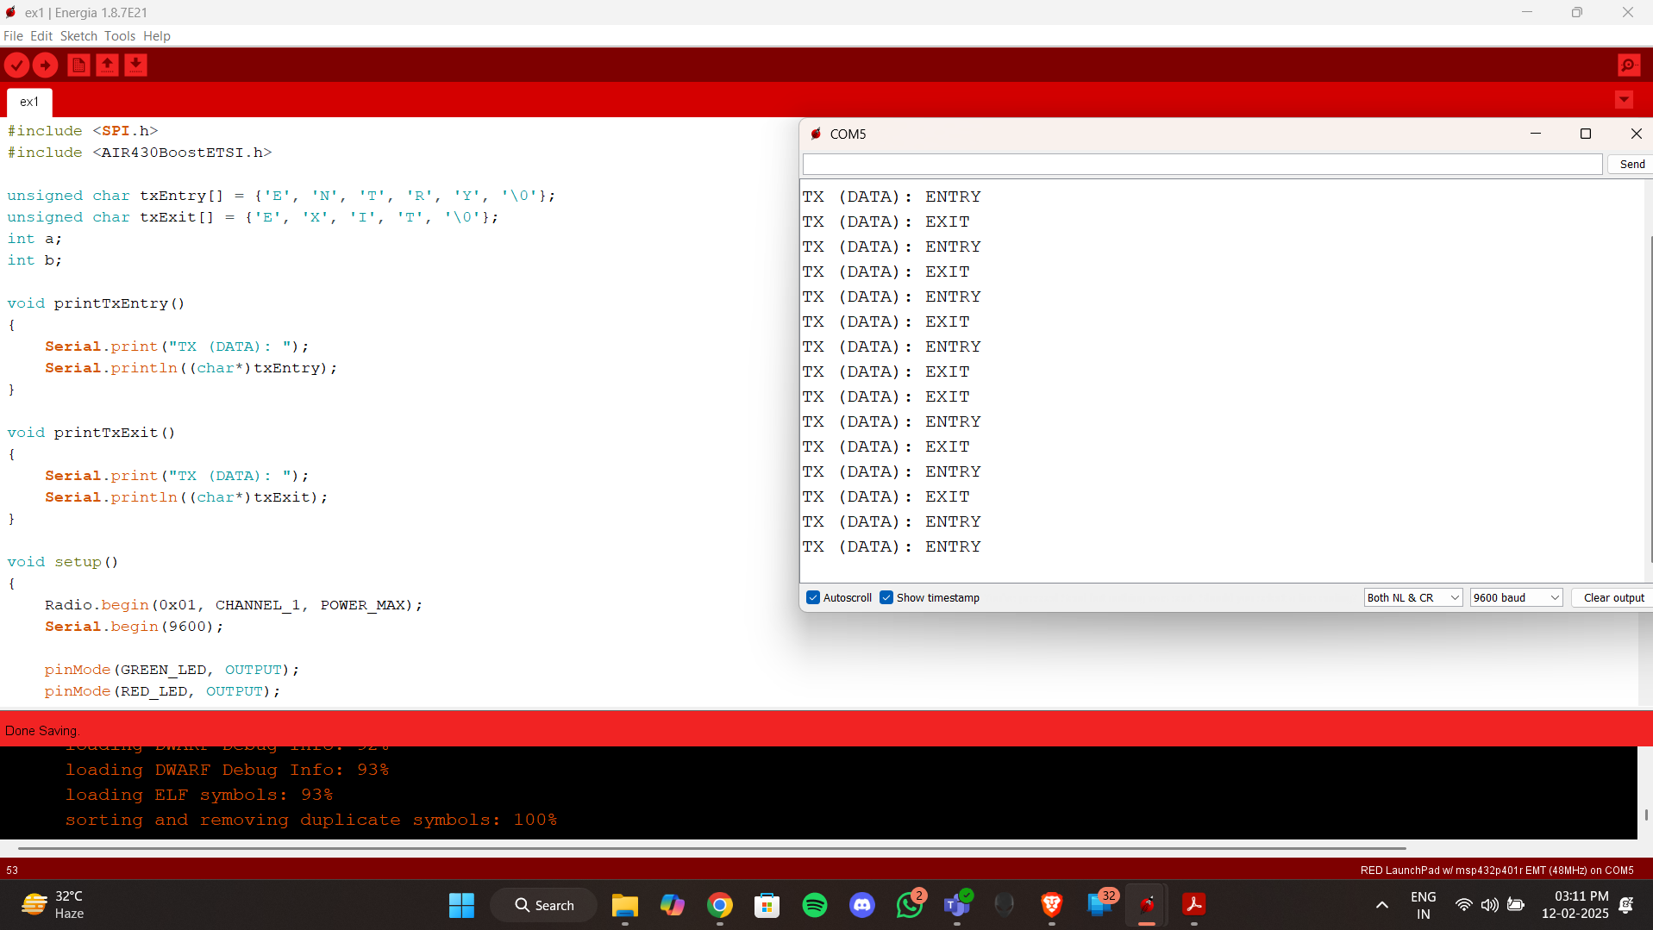

**Exercise Question 2:** Develop an algorithm for detecting the drive is drunk. Use onboard pushbutton as alcohol sensor, with 2 conditions. Condition 1: the driver can start the car only by giving his breath test to the sensor (Pushbutton 1), if then sensors remains low and onboard RBG LED can be green and driver can start the car. If the sensor is HIGH (Pushbutton 1) the message is sent to the police station with the driver car number turning RGB LED to red forever.  
